Aero Admin (Remote Support Software Guide)
IT To Go – Computer Services
THIS GUIDE IS BEST FOLLOWED USING GOOGLE CROME AS YOUR BROWSER
Download Chrome by clicking here if you don’t already have it installed.
PLEASE NOTE – Help images are provided, and the areas of interest or to click are highlighted in red.
1. Look for your Google Chrome or your browser of choice once you have the icon on the desktop or start menu you can double click to load the browser.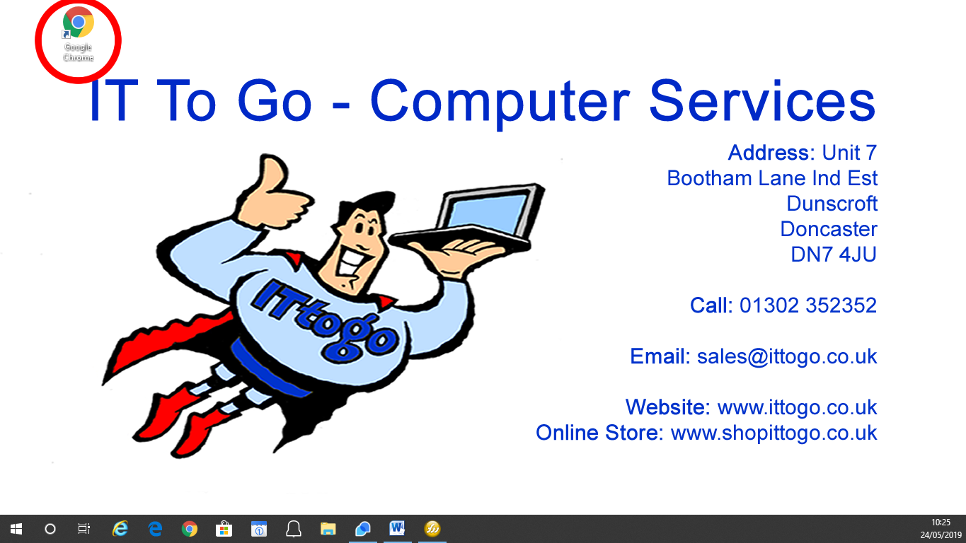
2. Then type into a Google search “Aero Admin”.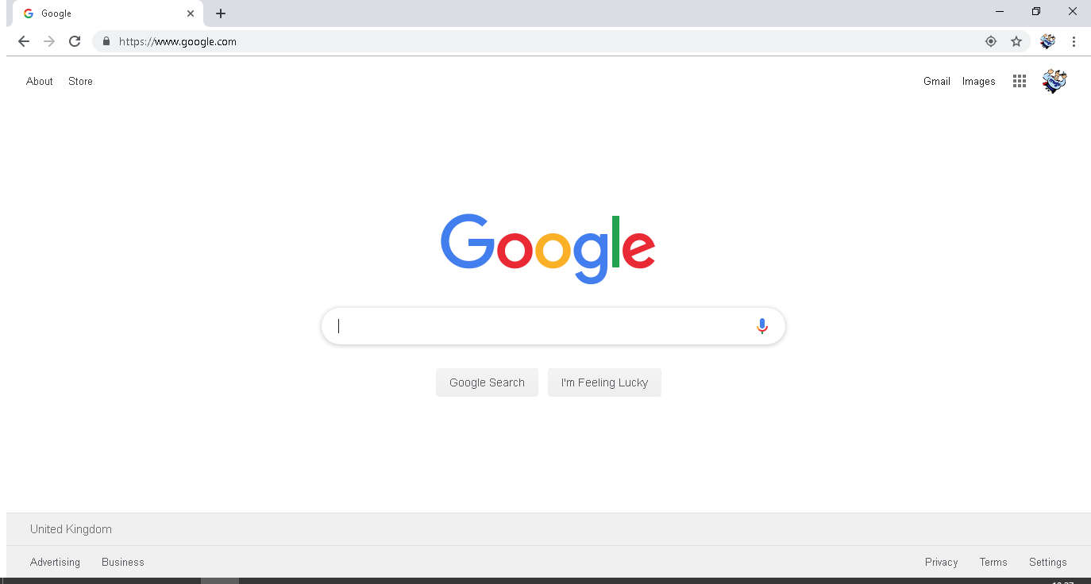
3. You are now looking for the search like below: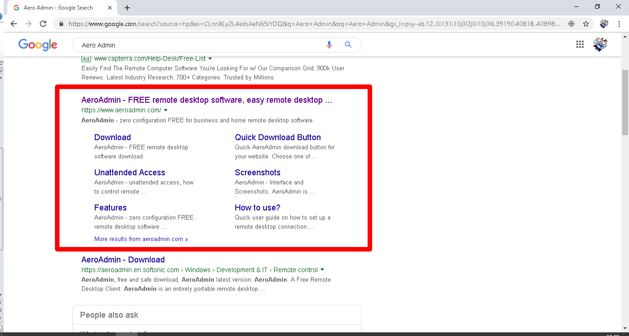
4. Click the top option “AeroAdmin – FREE remote desktop software and remote desktop” .
5. You will now be sent to the remote website where you can click the “Download AeroAdmin” button in orange.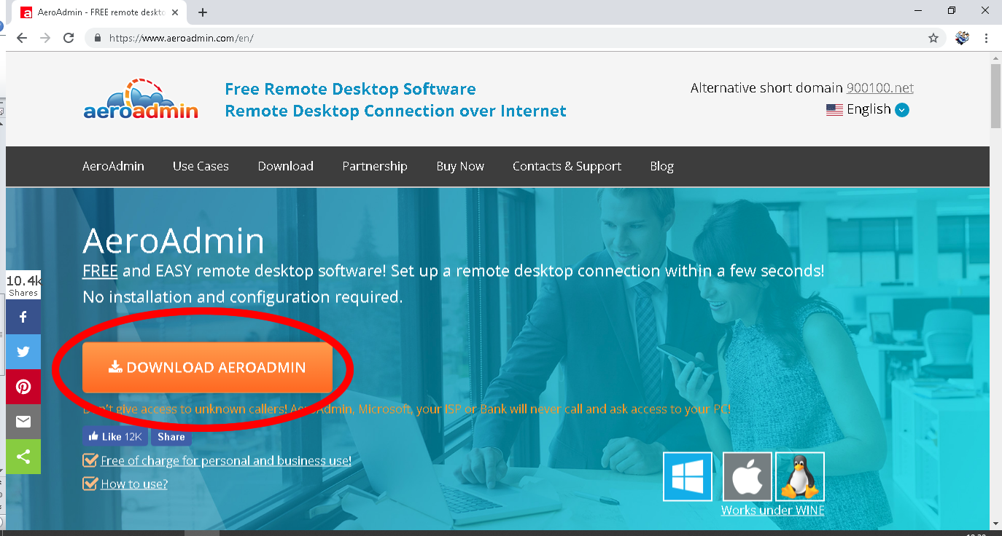

6. The program will now load in the lower left corner please wait until the icon no longer says downloading, and then click.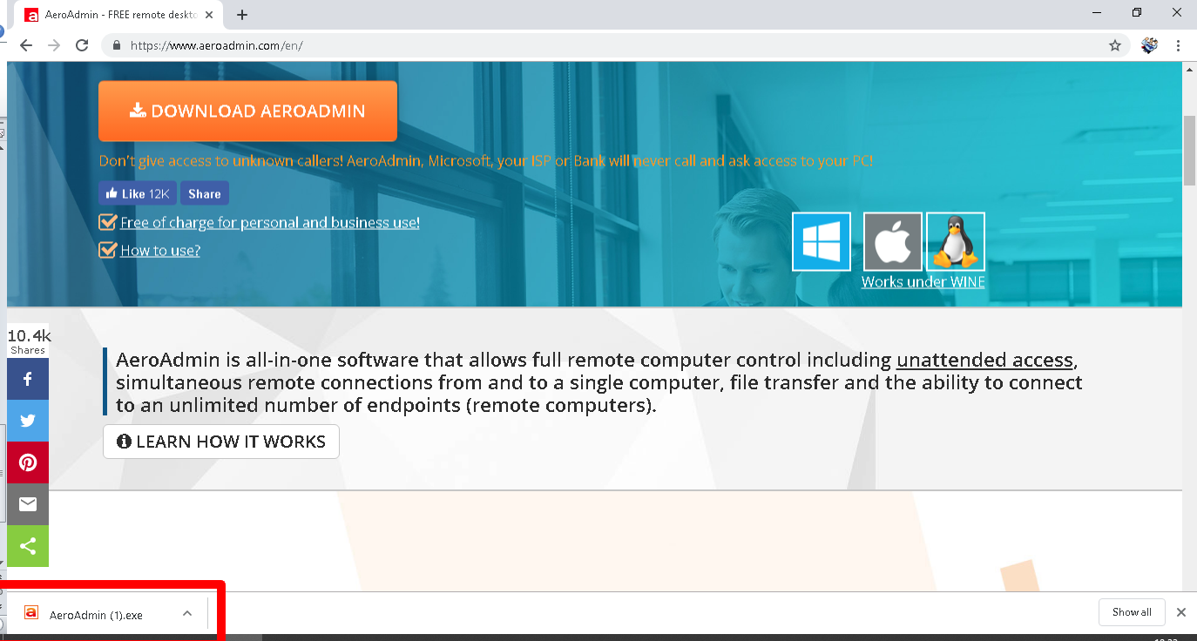
7. This will then open the software.
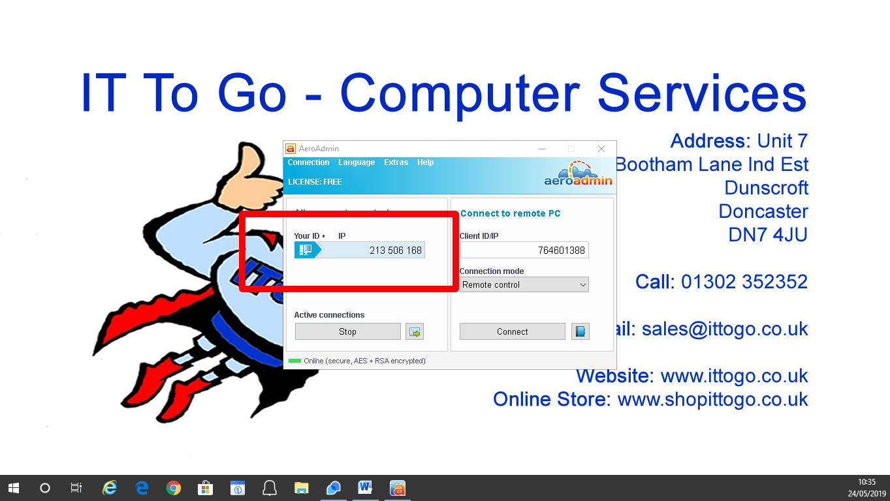
8. You are now ready to call support and quote the “Your ID” in the allow remote control box of the software, just the 9 digit code.
9. You will then be told Incoming Connection Request.
10. Ensure all the boxes are ticked in “Set access rights for this admin”
11. Then tick the box “I confirm I know this Technician and trust them.
12. Then click “Accept”
13. We should now be able to confirm control of your device.
13. Sit back and relax while we do all the work now!

